4.5 Alexander and the Hellenistic Age

Directions: These notes will cover the information on paths 158-200. You are responsible for filling in the blanks, and paying attention in class.
Focus Question: How did Alexander the Great expand his empire and spread the Greek culture throughout the realm?

Vocabulary
Assassination
Assimilate
Heliocentric
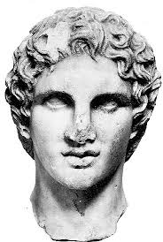

The Empire of Alexander the Great
- Alexander was a young man when he inherited the Macedonian empire from his father,_____Phillip 2 (the second)_______ . He grew the empire larger than any in history, and did not do it alone. In this speech, he rallies the troops to continue on in conquest…
  - "I could not have blame you for being the first to lose hear ____________ if I..had not shared in your exhausting marches and your perilous campaigns..You and I...have shared the ____________ and shared the danger, and the rewards are for us all..whoever wishes to return home will be allowed to go..I will make those who stay the envy of those who return."
  - In 338 BC, Athens fell to the Macedonian Army
    - Athens lost its __independence __________, but its culture spread all over the Mediterranean by the conquering of land by Alexander the Great.
  - The Empire of Alexander the Great
    - The Greeks viewed the Macedonians as rough , backward people.
    - The leaders were Greek in origin, however.
      - Philip II grew up in _____ and even hired Aristotle to tutor his son, Alexander.
    - Philip II came to power in 359 BC and wanted to conquer the lands to the south
      - He developed a powerful _____ and formed alliances with many other city-states (threat, bribery, diplomacy)
      - Others he conquered.
      - 338 BC - ____ and Thebes joined forces against Philip II
        - He defeated them in the Battle of _____ gave him all of Greece under his control.
        - He planned to take over the Persian empire but was assassinated at his daughter's wedding
          - One of his wives, _____ , outmaneuvered is other wives to put her son, Alexander, in power.
    - Alexander was 20 years old but was a good soldier and shared his father's ambitions
      - By 334 - Alexander had enough ships to cross the _____ , the strait separating Europe from Asia Minor
      - The Persian emperor, Darius III, was weak and many provinces were in rebellion.
      - Alexander was able to capture ____________, Egypt, and Babylon by 331 BC
      - Before he could capture Darius, the emperor was murdered.
  - Advance into India
    - crossed the Hindu Kush and into northern ____________ in 326 BC.
    - His troops faced war elephants for the first time.
    - Tired and weary, they ____________ to go further. Alexander turned back and planned his new campaign in Babylon
  - Alexander’s Early Death
    - Before setting out again, Alexander became sick with fever and ____________ at age 32.
    - Commanders asked who he would leave empire to...he is said to have whispered, “To the strongest.”
    - No one was strong enough, and after three years his generals ____________ the empire into three parts.
      - Macedonia and Greece
      - Egypt
      - most of Persia
    - Their descendants competed over this land for over 300 years
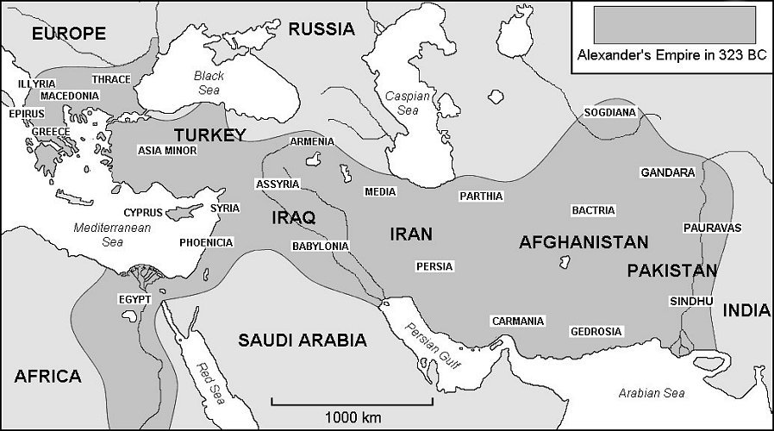
The Legacy of Alexander
  - his most lasting achievement was the spread of Greek ____________ in most of the world
  - Cultures Combine
    - Alexander founded cities (often named ____________) throughout the lands he captured.
    - Traders, soldiers, and artisans settled these cities.
    - Cities were filled with Greek temples, ____________ contests, and Greek statues
    - The people assimilated into Greek culture and they picked up the native traditions
    - Alexander married a ____________ woman, adopted their dress and encouraged soldiers to do so.
    - Created a culture that combined Egyptian, Persian and Greek aspects.
  - Alexandria: Cultural Capital
    - Alexandria, Egypt had a wide range of goods at market (Greek ____________, Arabian spices, East African ivory…)
    - Marvelous sight was a lighthouse that stood 440 feet in the air
    - Museum
      - center of learning with laboratories, lecture hall, and a ____________
      - the library had thousands of scrolls representing all the accumulated knowledge of the ancient world, but it was destroyed by ____________.
    - Women:
      - women were no longer restricted to their ____________ during the Hellenistic period
      - more learned to read and write
      - some were philosophers and ____________, or had considerable power alongside their husband and sons who were rulers
      - ____________ VII
Hellenistic Arts and Sciences
  - cities had armies of architects and ____________ to create buildings grander than those during classical Greece
  - New Philosophies - ____________
    - Political turmoil led to a new rise of philosophy
    - The founder, Zeno, urged others to avoid desires and disappointment by accepting what life gave them.
    - High moral standards, like protecting other humans
      - women and slaves were unequal socially, but were equal morally because they had the ability to ____________.
        - influenced Romans and Christians later
  - Math and Astronomy
    - built on ideas of Greeks, Persians, and Egyptians
    - ____________ created a formula to calculate the relationship between the sides of a right triangle
    - Euclid wrote the textbook that became the basis for ____________
    - Aristarchus argues that the Earth rotated on an axis and orbited the sun
      - This heliocentric idea, the sun at the center of the universe, was not accepted until ____________ years later.
    - Eratosthenes showed the earth was round and accurately calculated its circumference
    - Archimedes applied physics to make practical inventions using the lever and pulley.
      - used a ____________ to draw a ship over the land before a crowd
  - Improving Medicine
    - Hippocrates studied causes of ____________ around 400 BC and looked for cures.
    - Doctors take a Hippocratic Oath in order to protect the patients and set ethical standards.

4.5 Assessment Questions- this page !

- Why was Alexander the Great able to conquer the Persian empire?

- How did Alexander encourage the blending of cultures?

- How did Alexander’s conquests lead to a new civilization?

- Why do you think the Hippocratic Oath is considered a medical advancement?

- In what fields did Hellenistic civilization make advancements?

