3.1 Early Civilizations of India and Pakistan
You are responsible for filling in all the blanks, answering the questions in purple.

Focus Question: How have scholars learned about India's first two civilizations, the Indus and the Aryan? (See if you can answer this at the end of the lesson!)

Geography of the Indian Subcontinent
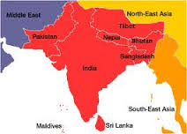
  - Early 1900s AD:
    - Archaeologists digging in the ___ River Valley unearthed artifacts from an unknown civilization believed to be 4,500 years old.
      - Bricks, clay seals, figurines, and other things...unlike any other civilization
  - This area is located in South Asia on the Indian ___
    - Includes 3/10 of the world's most ___ countries: India, Pakistan, Bangladesh
    - Also in this area: Sri Lanka, Nepal, Bhutan
    - ______ Mountains, Hindu Kush Mountains
      - Mountains served as a ______ for migration and limited contact with other lands
  - Natural Features Define Region
    - The subcontinent is divided into three regions:
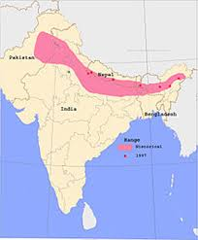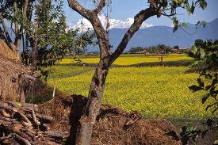
      - ______ Plain: South of the Himalayas. The Indus, Ganges and Brahmaputra Rivers bring melted snow from the mountains to allow farming
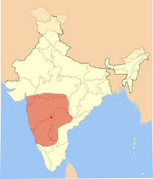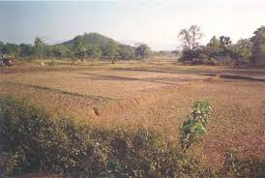
      - ______ Plateau: juts into the Indian Ocean, lacks water for irrigation. Arid, agriculturally unproductive and sparsely populated
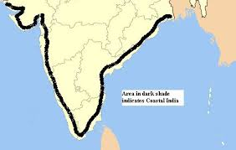
      - ______ Plains: Rivers and heavy seasonal rains provide water for farmers. Used the seas for fishing and highways for trade.
    - Monsoons: (Take notes from the video)

How has geography affected where people live in the Indian subcontinent?

Indus Civilization Rises and Falls
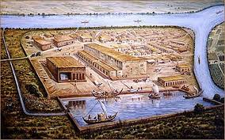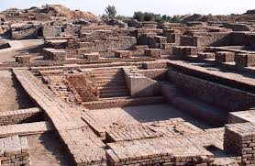
  - Little is known about these people because there is little ______ record.
  - It covered the largest ______ of all ancient civilizations until Persia. Rivaled Sumer in size.
  - Well planned cities reveal ______ governments
    - Harappa, Mohenjo-Daro
    - ______ city layout
    - ______ bricks
    - Complex plumbing
  - Farming and Trading
    - Farmers grew wheat, barley, ______ and dates
      - May have been the first to cultivate ______ to make cloth
    - Traders carried goods to distant areas
      - Contact with Sumer may have prompted them to create a form of ______
    - Religion
      - Believed to be ______
        - Honored mother goddess of creation
        - Possibly a head male god
        - Held buffalo and bull ______
        - May have influenced the Indian belief in the ______ of cattle
    - Decline
      - By 1900 BC, quality of life was ______
        - ______ pottery replaced finer works
        - Writing stopped
        - Populations ______
      - Scholars think a combination of deforestation, ______ and earthquakes led to this.
    - What evidence shows that Indus civilizations included a well organized government?

Aryan Civilization Develops During Vedic Age
  - Aryans migrated to ______
    - Moved across Europe and Asia following herds
      - Crossed ______ paths into region
      - Left little evidence except for Vedas
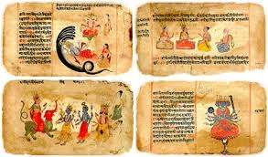
        - ______ : a collection of hymns, chants, ritual instructions and other religious teachings
          - Recited and memorized by priests for 1000s of years before ______ down
      - Aryan Culture
        - ______ herders that valued cattle (provided food and clothing)
        - Loved food, drink, music, ______ races and games
        - When they settled, wealth was determined in the number of ______ you owned
  - Nomadic Life to Farming
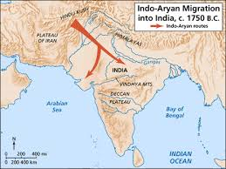
    - Learned how to farm
      - Settled in ______ to cultivate crops and breed cattle
    - 800 BC - spread to the ______ basin and made tools out of iron. Some made farms and villages in the rainforest
    - ______ led tribe, who was elected to position. Consulted with council of elders
      - Powerful rajahs extended their power to other ______
  - Aryans Structure Society
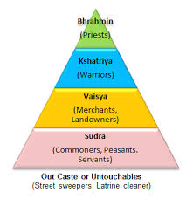
    - Divided society into ranked groups by occupations
      - Highest: Brahmins (______ )
      - Kshatriyas (______ )
      - Vaisyas (herders, ______ , artisans, merchants)
      - Sunras (farmworkers, ______ , laborers, those with no heritage)

- Rig Veda "Hymn of Man"
  - "When they divided Purusha, in how many different portions did they arrange him? What became of his mouth, what of his two arms? What were his two thighs and his two feet called? His mouth became the Brahmin; his two arms were made in the Kshatriya; his two thighs were the Vaisya; from his two feet the Sunra were born."
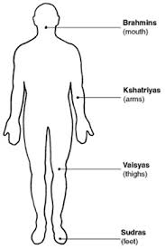
- Religious Beliefs Develop
  - Aryans were polytheistic
    - Worshipped gods that embodied ______ forces (sun, sky, rain)
    - ______
      - Chief deity
      - God of war
      - Thunderbolt - destroys demons and announces rain
    - ______
      - god of fire who communicated human wishes to gods
  - Brahmin Sacrifice
    - Brahmins offered food and drink to gods for ______
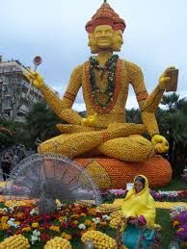
    - Aryans believed they could call on gods for health, wealth and victory in war.
  - Change in religion

    - Some moved to belief in ______ powerful god that resided in all things
      - Known as Brahman
    - ______ sought direct communication with the gods
      - Aryan mystics practiced ______ and yoga to enhance the attempt to achieve direct contact with the divine
    - Brahmans and Mystics later influenced later Indian religion

3.1 Assessment Questions:
- Describe two ways in which geography and climate have influenced the people on the Indian subcontinent. (Climate is weather over a long period of time. We have hot summers.)
- What types of evidence could archaeologists look for to explain how the Indus civilization declined?
- How was Aryan society structured?

